
SPECIALIST MATHS
TRIAL EXAMINATION 1
SOLUTIONS
2006

_____________________________________________________________________

Question 1

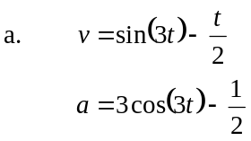

(1 mark)

- 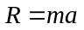 where R is the magnitude of the resultant force.
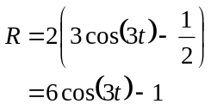
(1 mark)
R is a maximum when 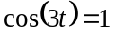; that is, when 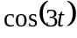 equals its maximum value.
So, the maximum value of R is given by
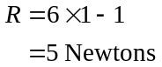
(1 mark)

(1 mark)

Question 2

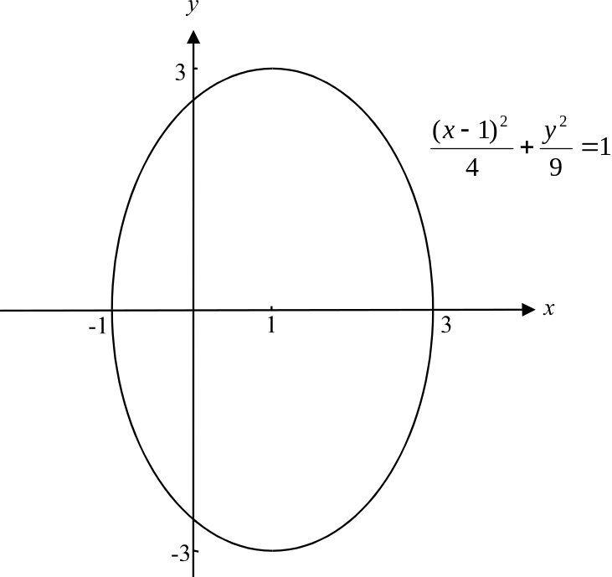

(1 mark) correct shape with
points 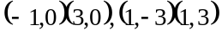 shown
(1 mark) correct centre
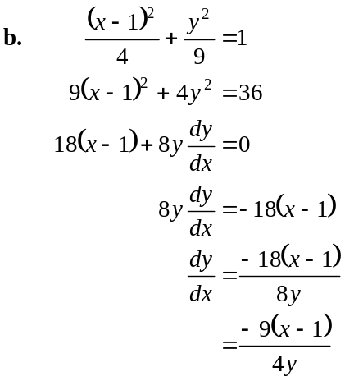Dra
(1 mark) for differentiating x term and constant term
(1 mark) for differentiating y term
(1 mark)
(implicit differentiation)

- If 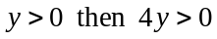 __________(A)

For 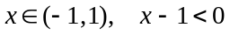
so 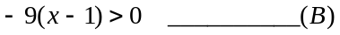 (1 mark)
Using (A) and (B), we have
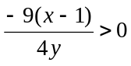
Therefore 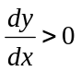 since 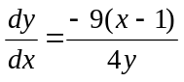
(1 mark)
So 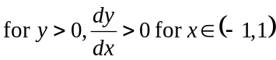.
Question 3

- Let 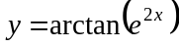
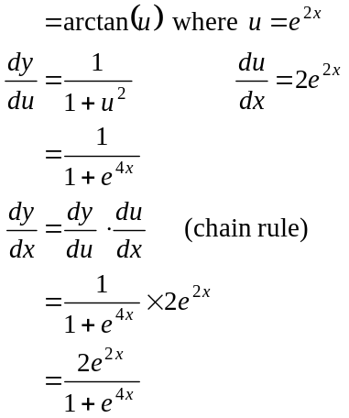
as required. (1 mark)

- From a. 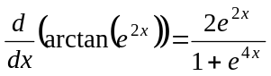
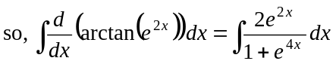
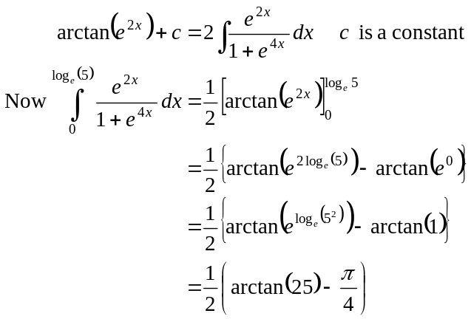
(1 mark)
(1 mark)

(1 mark)

(1 mark)

(1 mark)

(1 mark)

(1 mark)
(1 mark)
(1 mark)
(1 mark)
(1 mark)

(1 mark)

Question 4

- If 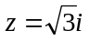 is a solution to the equation 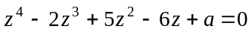 then
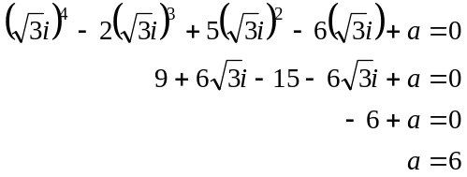
(1 mark)

- Since all the coefficients of the equation are real, one other solution is 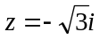 since the solutions occur in conjugate pairs (conjugate root theorem).
(1 mark)

Method 1
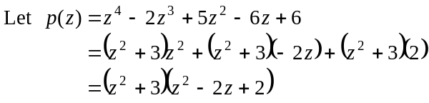
(1 mark)

Method 2
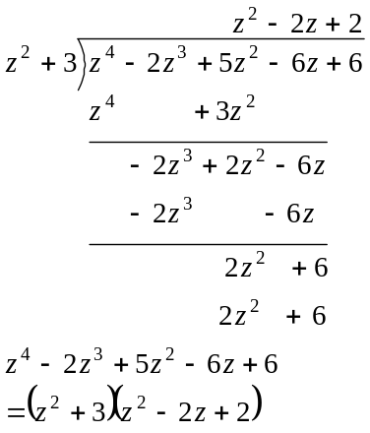
(1 mark)
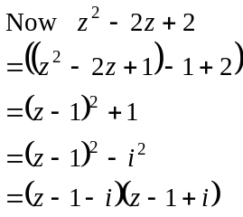
All the solutions to 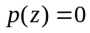are therefore 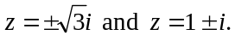
(1 mark)

W

(1 mark)
(1 mark)

(1 mark)
(1 mark)

(1 mark)
(1 mark)
(1 mark) change of terminals

Question 5

(1 mark)

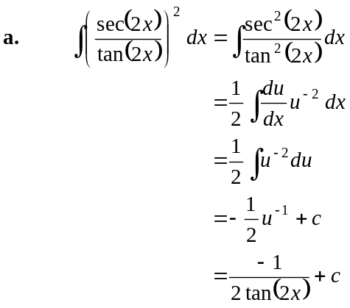
(1 mark)

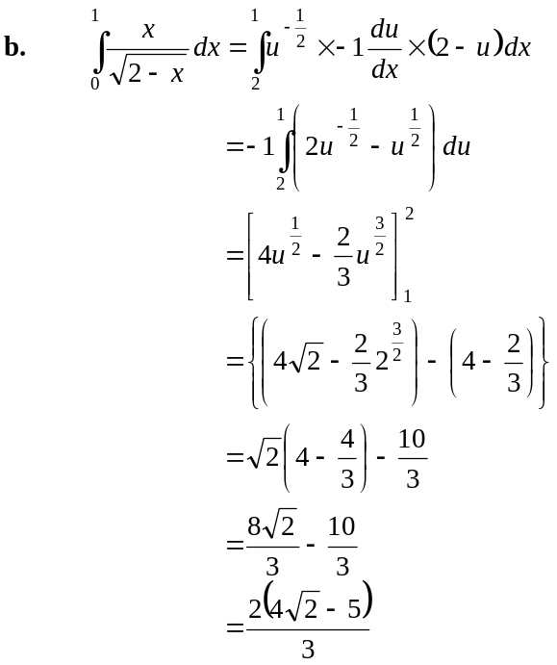
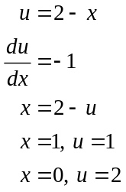
(1 mark) for integrand
(1 mark) for terminals

(1 mark)

Question 6

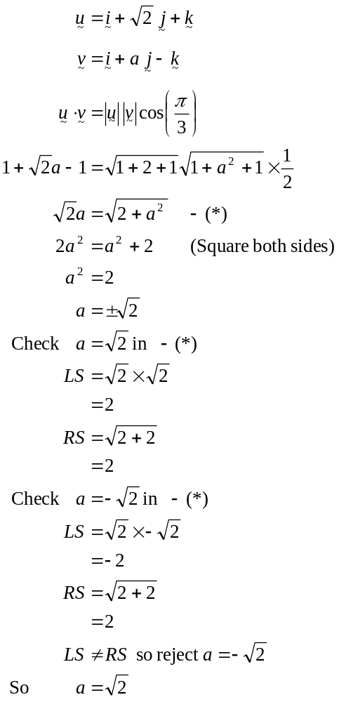
(1 mark)
(1 mark)
(1 mark)
(1 mark) for rejecting 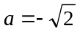.
(Note – when you square both sides of an equation it is important that you verify any resulting solutions.)
Question 7

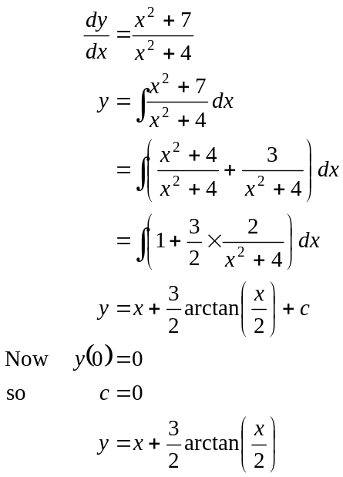
(1 mark)
(1 mark)
(1 mark)

Question 8

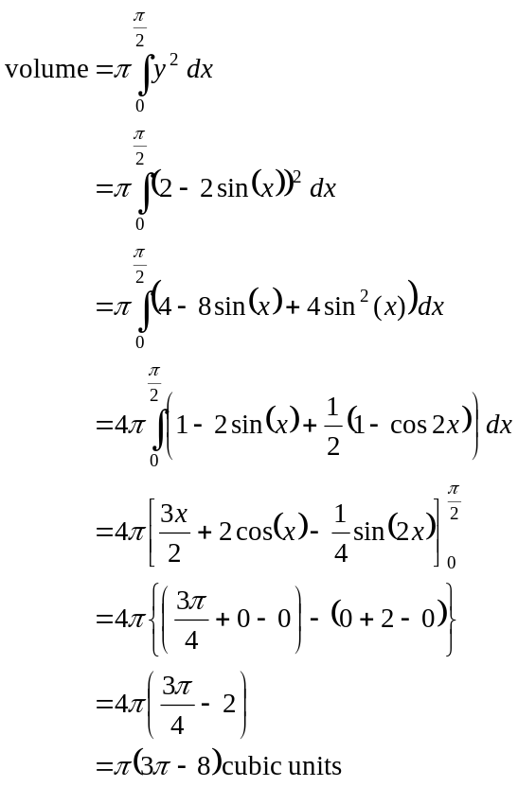
(1 mark)
(1 mark)
(1 mark)
(1 mark)

Question 9

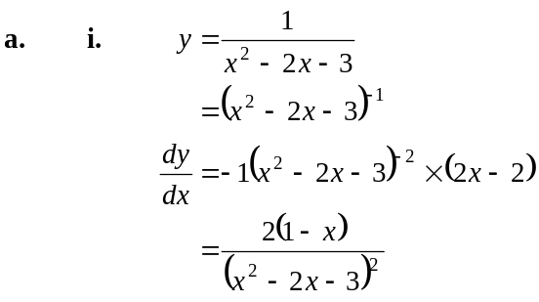
(1 mark)
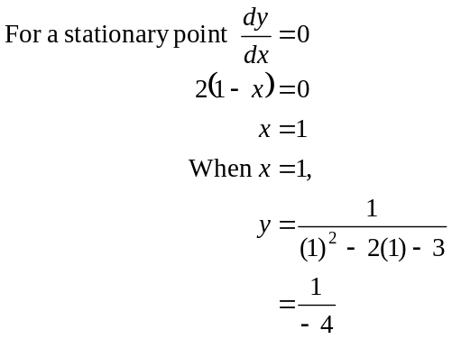
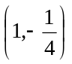 is the stationary point.
(1 mark)

- For 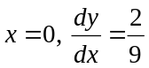
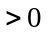
For 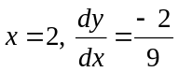
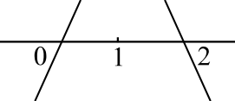
< 0
There is a maximum turning point at .
(1 mark)

- 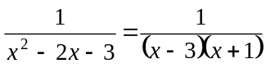
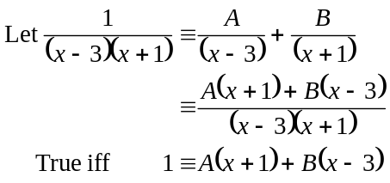
(1 mark)
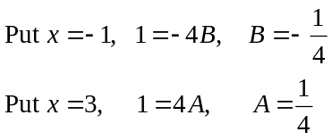
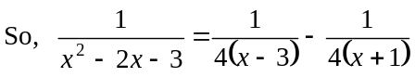
(1 mark)

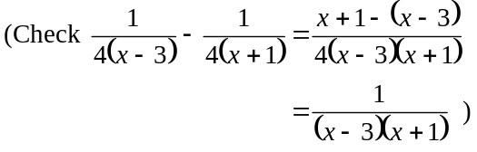

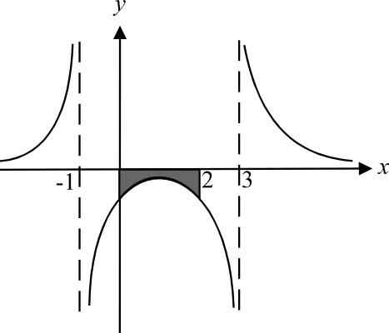
- Do a fast sketch.
From a. we know that
there is a max. tp. at
and no other stationary points.
There are asymptotes at 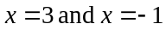.
The area required is shaded in the diagram.
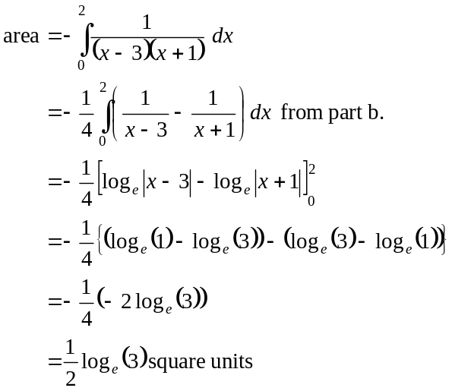
(1 mark)
(1 mark)

